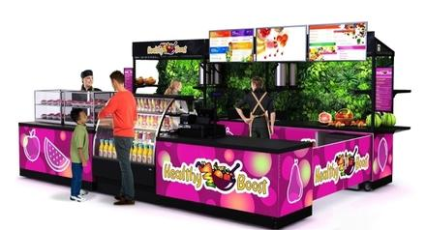
WE OFFER A WIDE RANGE OF ALL NATURAL BLENDED JUICES / SMOOTHIES AND SUPER TASTY FRUIT BOWLS

We place our kiosk in the following locations:

- Airports
- College Campuses
- Hospitals
- Office Buildings
- High Traffic Convenience Stores
- Malls

